**ASSIGNMENT 07:**

**You have,**

**One Jenkins Master server.**

**Three slaves- slave-1, slave-2, slave-3.**

**One Git Repository with multiple branches- 23Q1, 23Q2, 23Q3.**

**Every branch has its own individual index.html.**

**You have to deploy 23Q1 branch on slave-1, 23Q2 branch on slave-2 & 23Q3 branch on slave-3, With the help of multibranch pipeline.**

**Step 1:** Prepared Jenkins Master server, by installing java11, Apache tomcat and Jenkins.war.

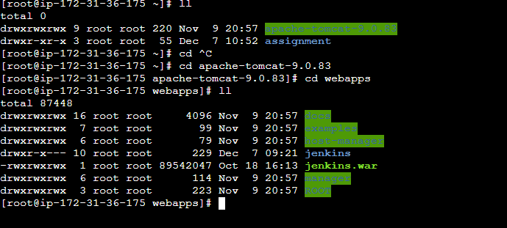

**Step 2:** Launched 3 EC2 instances as a slave, slave-1, slave-2, slave-3

Installed Java & Git on all three Slaves.

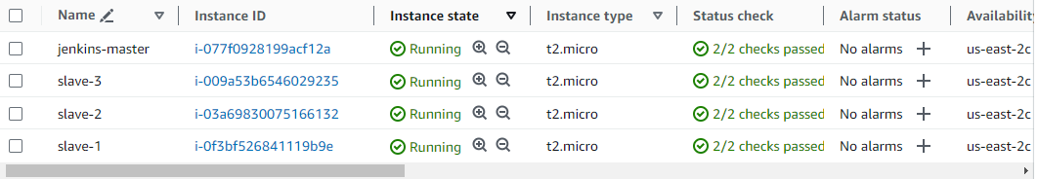

**Step 3:** Configured Jenkins Master slave connection with 1 Master with 3 slaves

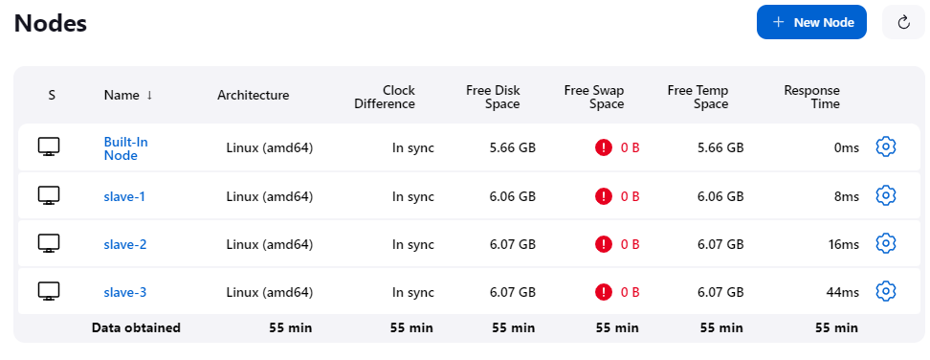

**Step 4:** Created a Git Local repository (multi-branch) with 3 branches (23Q1, 23Q2, 23Q3) having individual index.html file in all three branches. Also created Jenkinsfile for each branch.

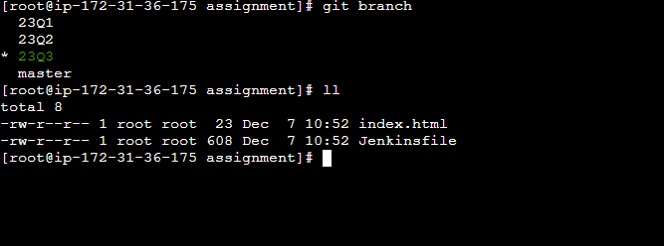

**Step 5:** After that I created a multibranch Pipeline in Jenkins:

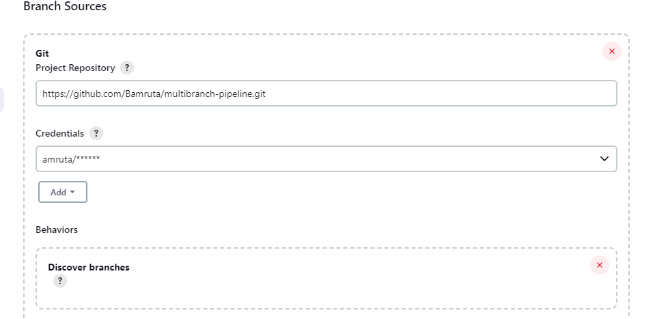

**Step 6:** After saving, can see 3 jobs are created.

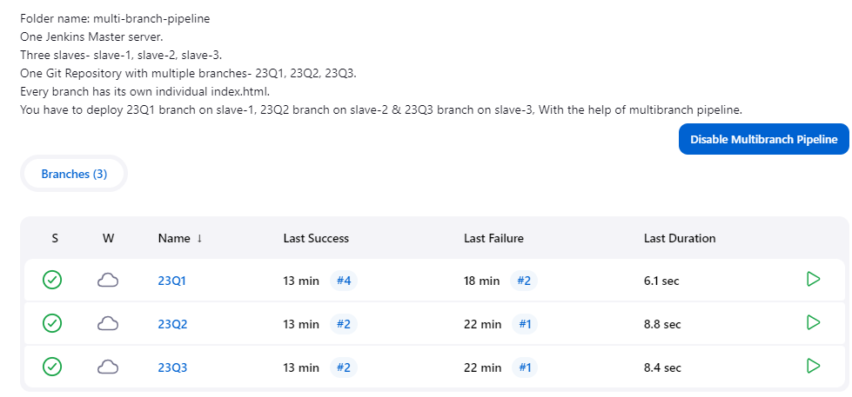

**Job-for branch 23Q1**



**Job-for branch 23Q2**



**Job-for branch 23Q3**



**Build all job successfully**

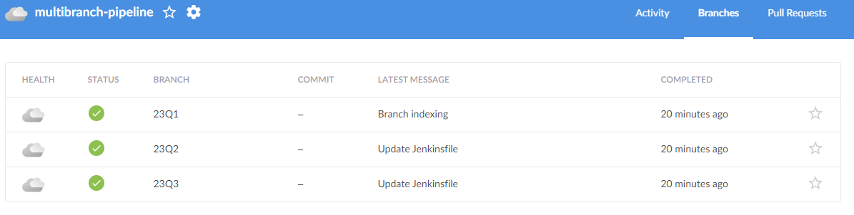

**-: OUTPUT :-**







**-: SCRIPTS :-**

**Jenkinsfile -23Q1:**

|  |
| --- |
| pipeline{  agent{  label{  label "slave-1"  customWorkspace "/mnt/workspace"  }  }  stages{  stage("httpd-install"){  steps{  sh "sudo yum install httpd -y"  sh "sudo service httpd start"  }  }  stage("clone-repo"){  steps{  git branch: '23Q1', changelog: false, credentialsId: 'git-token', poll: false, url: 'https://github.com/pskarne/multi-branch.git'  }  }  stage("deploy httpd"){  steps{  sh "sudo chmod -R 777 /var/www/html"  sh "cp index.html /var/www/html/"  }  }  }  } |

**Jenkinsfile -23Q2:**

|  |
| --- |
| pipeline{  agent{  label{  label "slave-2"  customWorkspace "/mnt/workspace"  }  }  stages{  stage("httpd-install"){  steps{  sh "sudo yum install httpd -y"  sh "sudo service httpd start"  }  }  stage("clone-repo"){  steps{  git branch: '23Q2', changelog: false, credentialsId: 'git-token', poll: false, url: 'https://github.com/pskarne/multi-branch.git'  }  }  stage("deploy httpd"){  steps{  sh "sudo chmod -R 777 /var/www/html"  sh "cp index.html /var/www/html/"  }  }  }  } |

**Jenkinsfile -23Q3:**

|  |
| --- |
| pipeline{  agent{  label{  label "slave-3"  customWorkspace "/mnt/workspace"  }  }  stages{  stage("httpd-install"){  steps{  sh "sudo yum install httpd -y"  sh "sudo service httpd start"  }  }  stage("clone-repo"){  steps{  git branch: '23Q3', changelog: false, credentialsId: 'git-token', poll: false, url: 'https://github.com/pskarne/multi-branch.git'  }  }  stage("deploy httpd "){  steps{  sh "sudo chmod -R 777 /var/www/html"  sh "cp index.html /var/www/html/"  }  }  }  } |